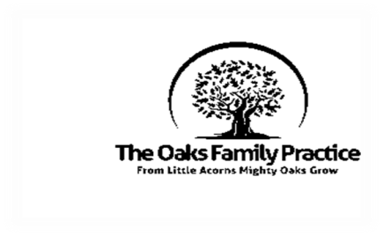
The Oaks Family Practice
New Patient Registration Form for Children <18

Child’s Name

Gender

Date Of Birth

Place of birth

Ethnicity
Main Language Spoken
Current School/Nursery
Current Address
Previous Address

YES/NO
Does the child have any medical conditions?
Please state if yes

Does the child have any additional needs?
Please state if yes

Do you consider your child to have a disability?
Please state if yes

Does the child take ay regular medication?
Please state if yes

Does the child have any allergies?
Please state if yes

Who else lives in the household with the child?
Name | Age/Date of Birth | Relationship to child

 | YES/NO
Do you have parental responsibility for the child?

Is the child you are registering ‘looked after’ by the local authority or subject of a child protection plan?

Is the child a carer for you or someone else?  Please state who if yes | For more support check out: http://www.bolton.gov.uk/website/pages/young carers.aspx
Do you know the name of the child’s health visitor/school nurse?
Please state who if yes

Is there anything else you think the practice needs to be aware of?

Does the child/your family have a social worker?
Please state who if yes

Name of person completing this form

Relationship to the child

Signature

Date

